**Core Services Course**

**Cloud IAM – Identity and Access Management**

Who can do, What, on which resource

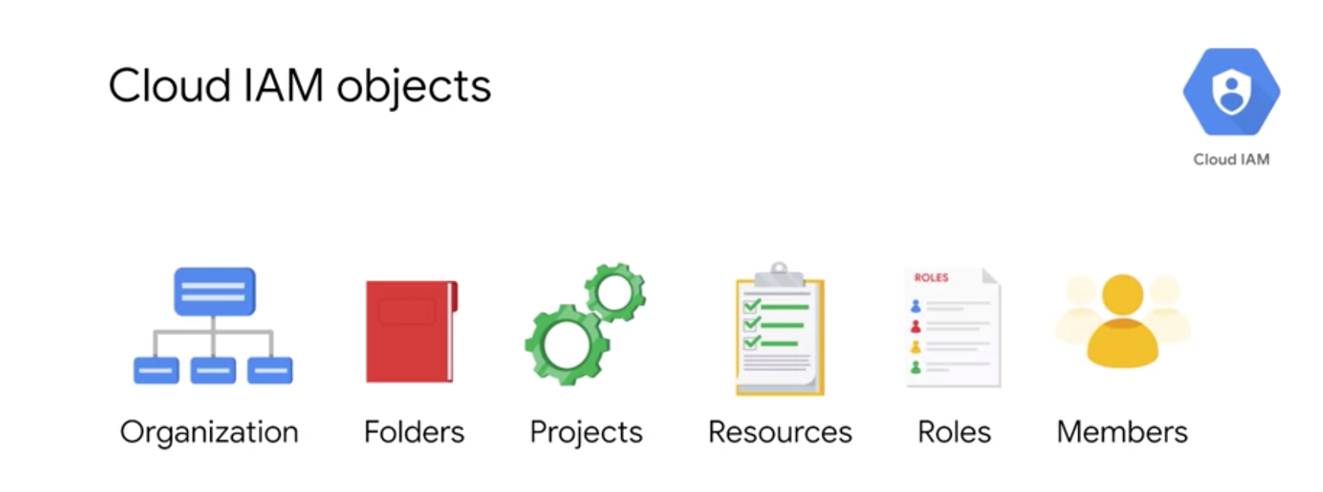

To take look at where these objects fit in, let’s take a look at the resource hierarchy.

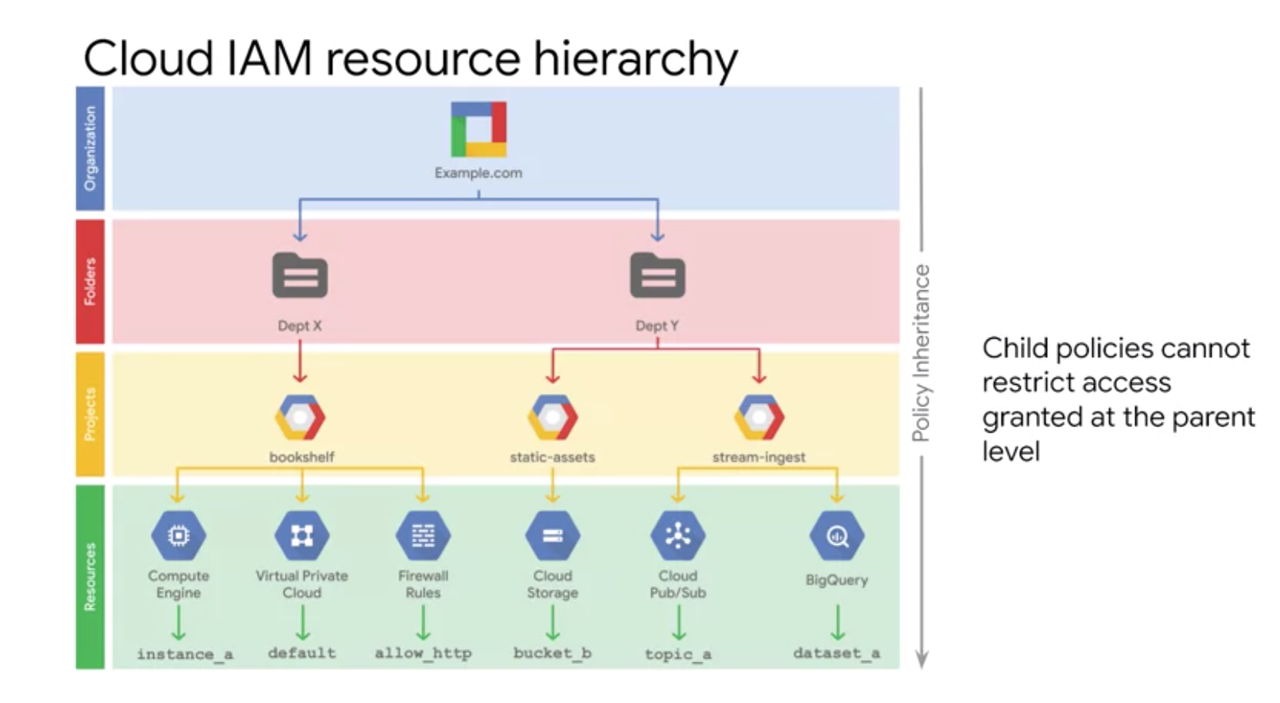

IAM allows you to set policies at all of these levels – where a policy contains roles and role members. IAM policy hierarchy always follows same path as GCP resource hierarchy.

Child policies cannot restrict access granted at the parent level. So, the best practice is to follow principle of least privilege. The principle applies to identities, roles and resources. Always select smallest scope that is necessary for the task to reduce your exposure to the risk.

**ORGANIZATION**

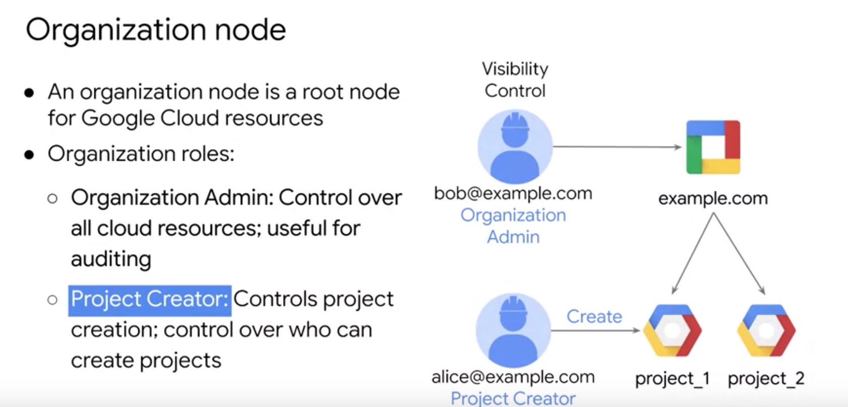

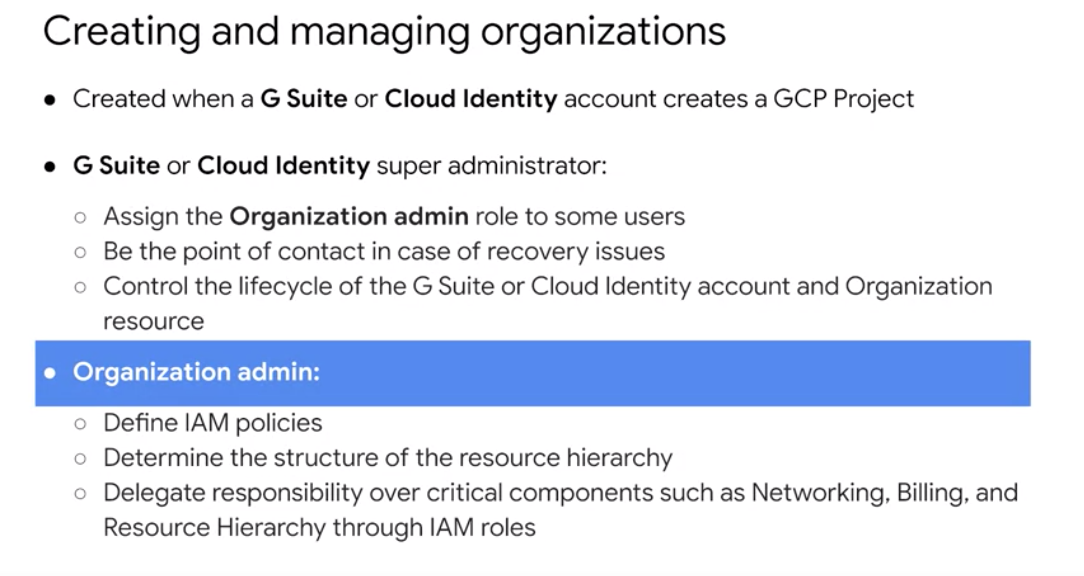

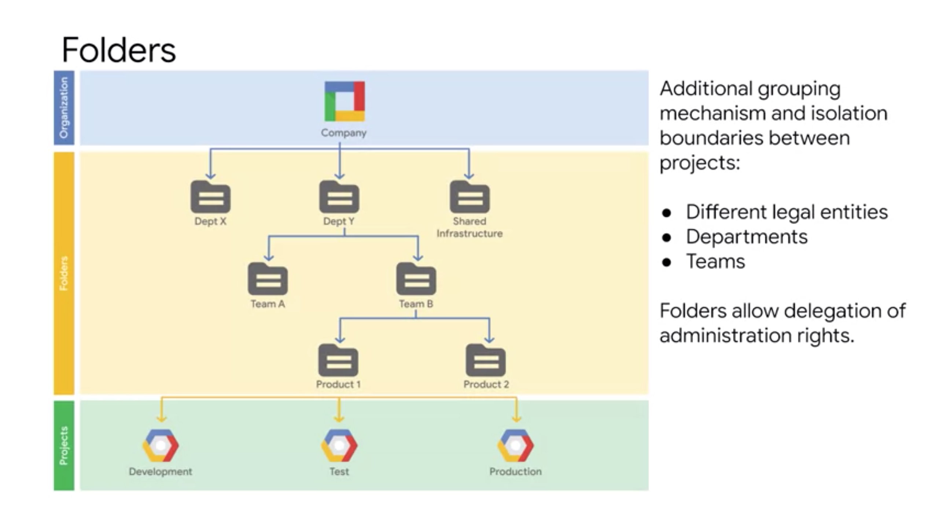

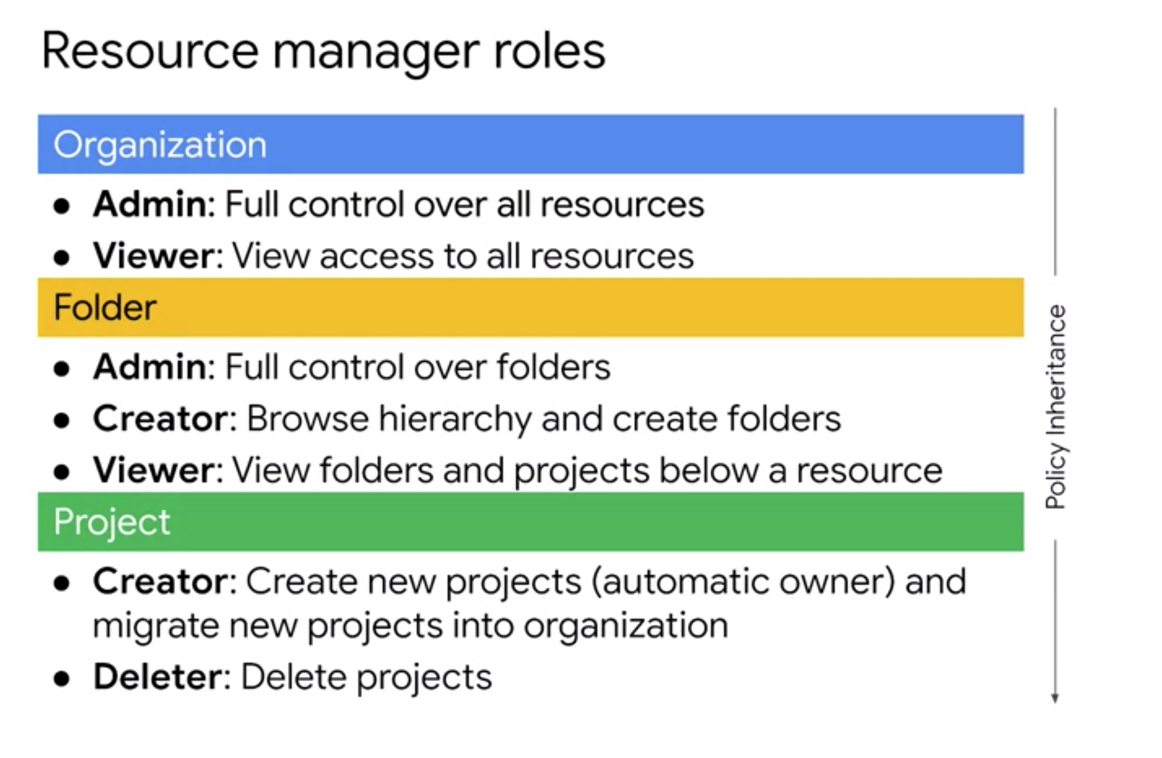

**ROLES**

3 Types of roles available

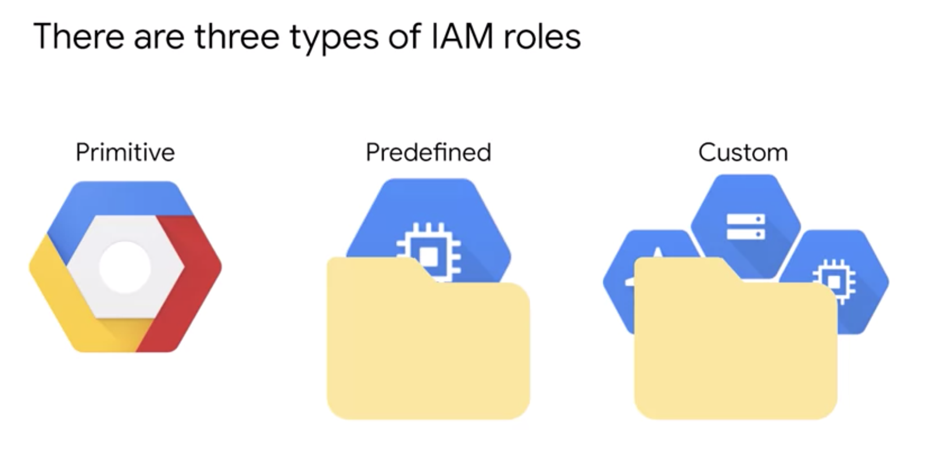

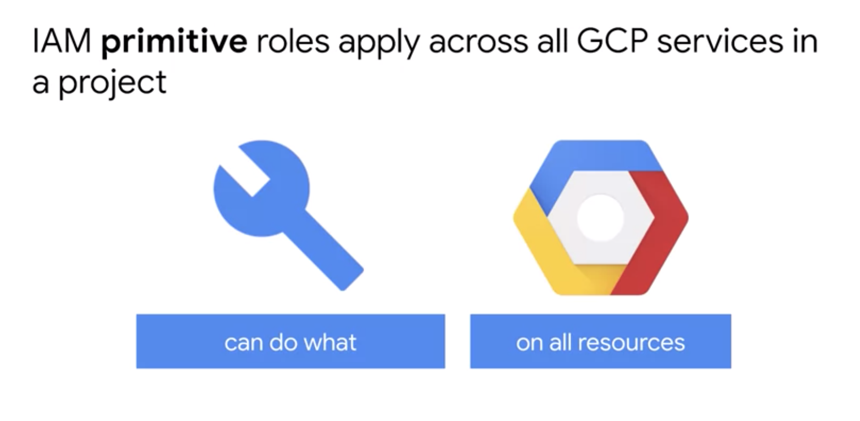

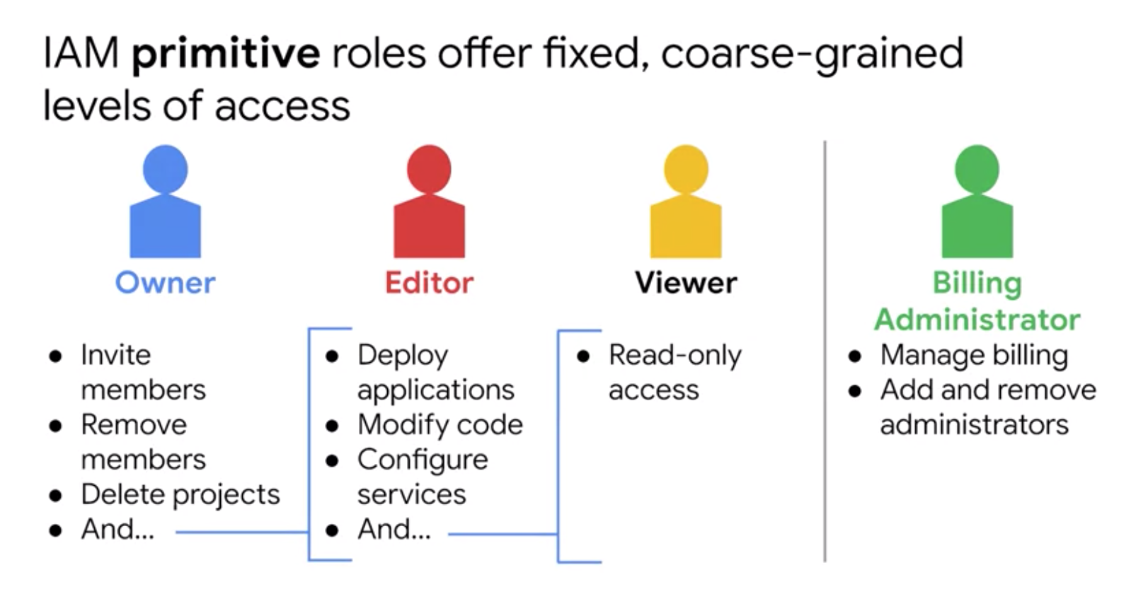

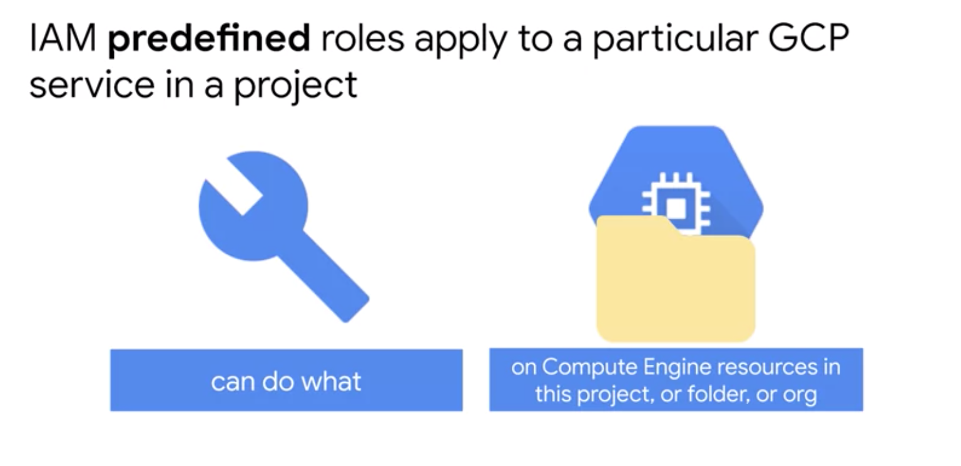

Example – instance admin role on project A

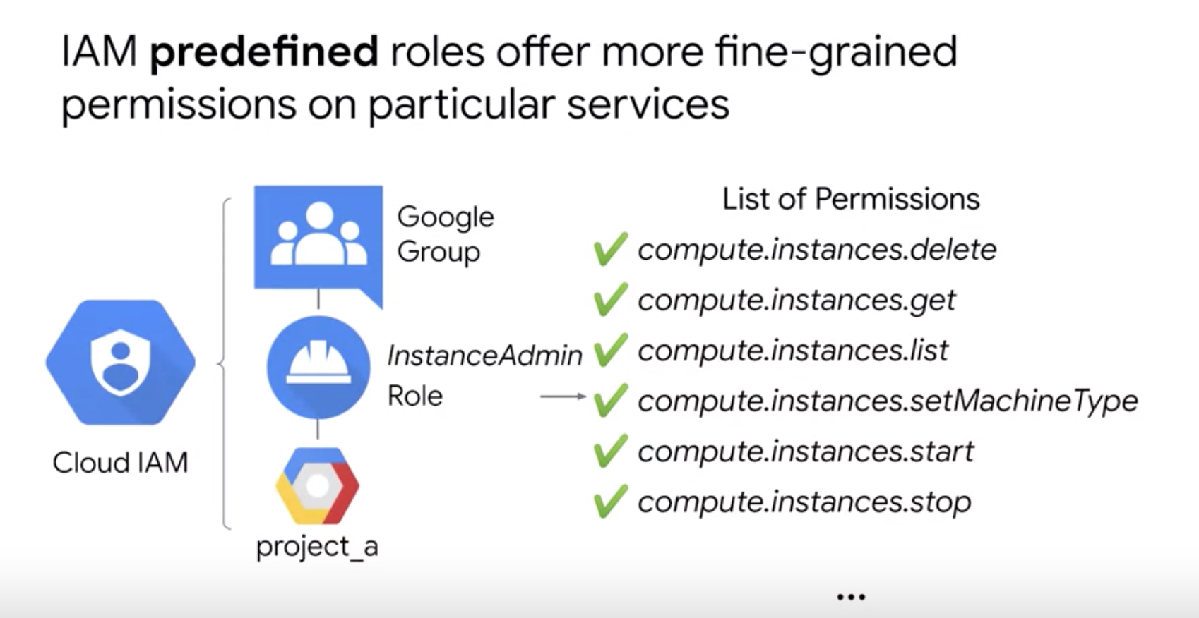

Permissions are methods/APIs for the service. Notation is Service.Resource.Verb. Eample – compute.instances.stop is permission to stop a compute engine instance.

Compute Engine has several predefined IAM roles

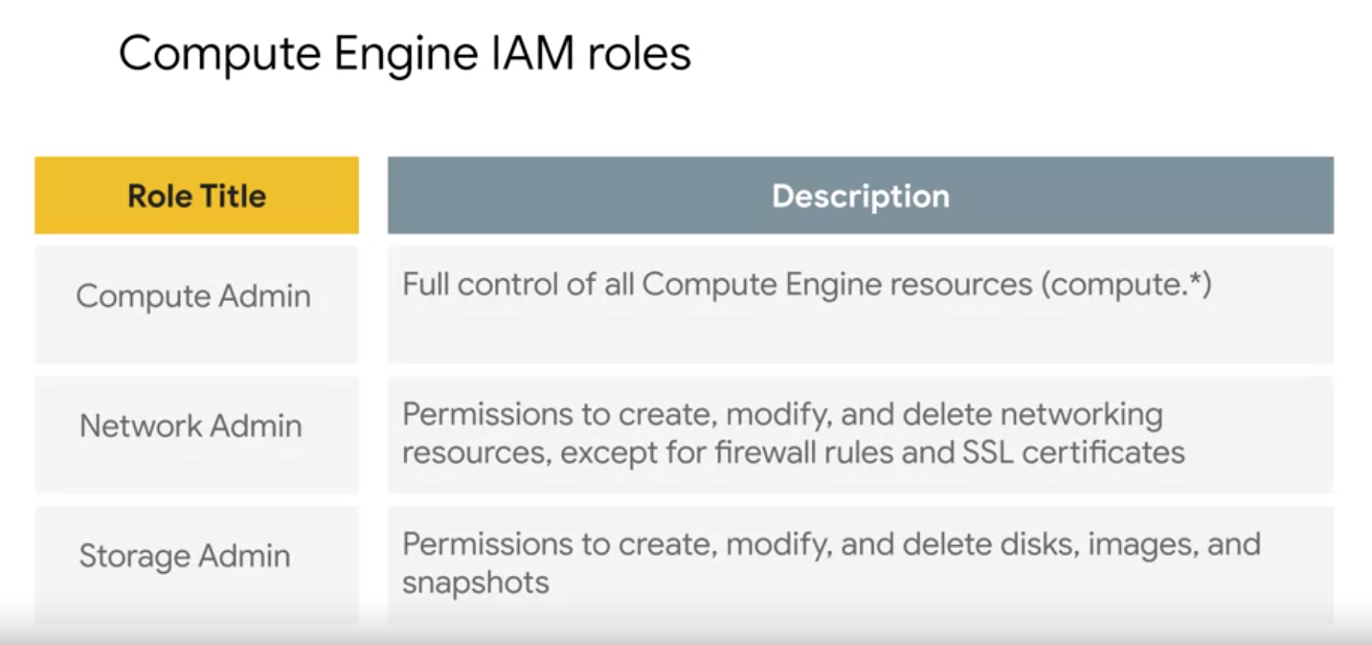

For more fine-grain set of roles, use custom roles

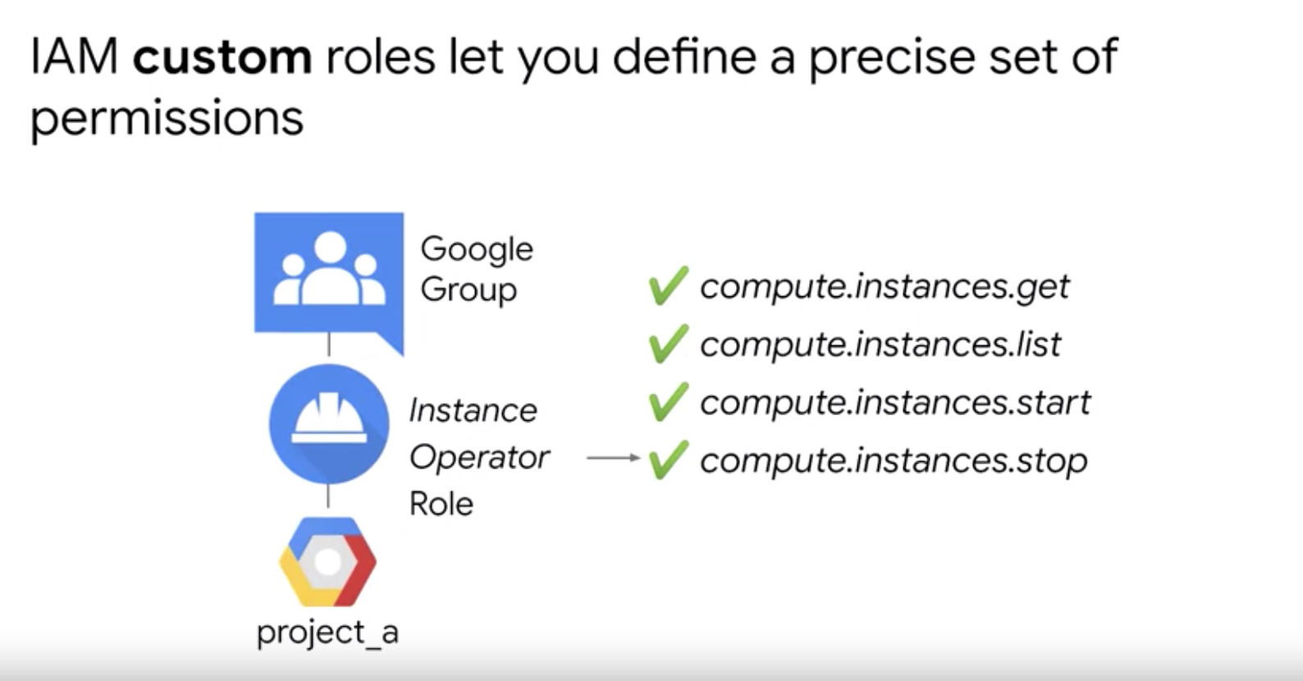

**MEMBERS** – who part - 5 types of members

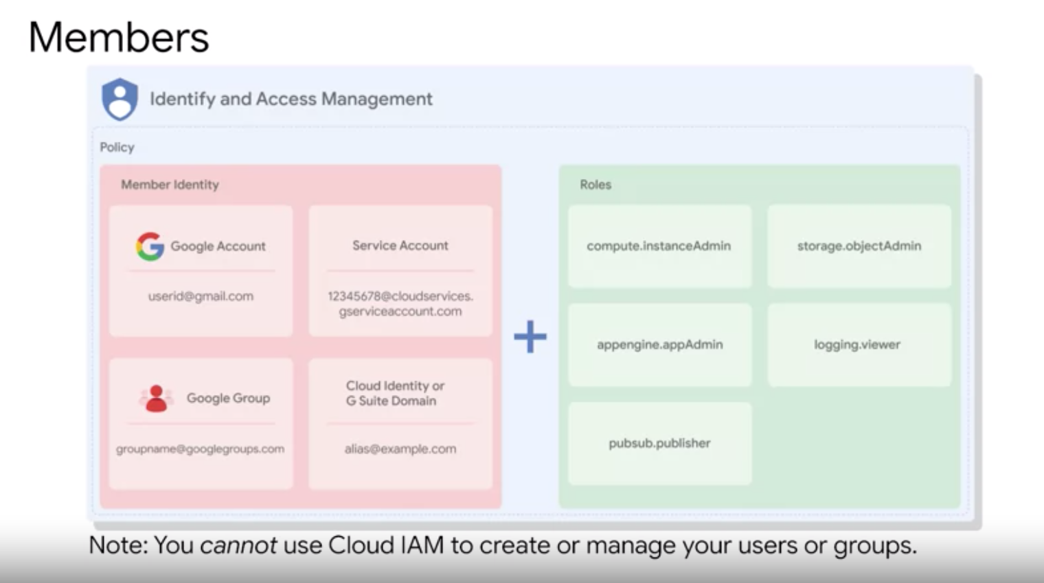

**SERVICE ACCOUNTS** – is a type of member

Account that belongs to an application instead of an individual end user.

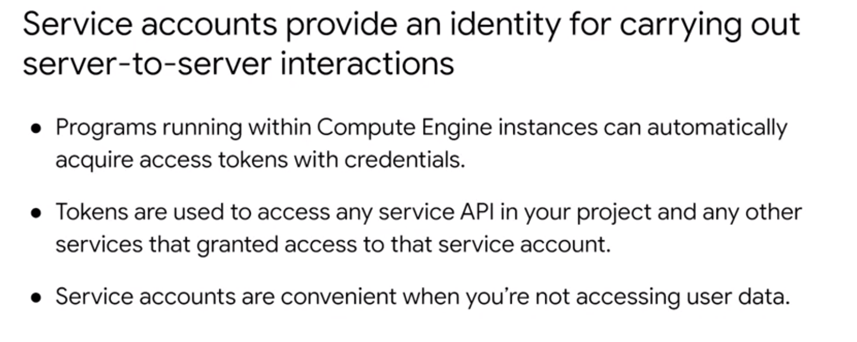

Service accounts are identified by an email address.

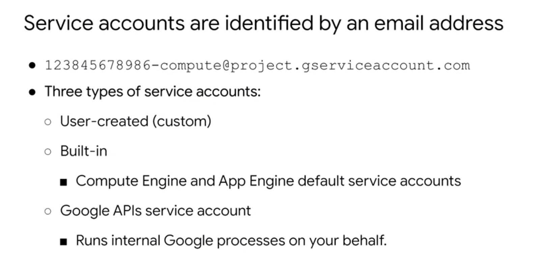

You can create any number of custom service accounts assign any arbitrary access scopes or assign roles to them and assign the account to any VM instance.

Default compute engine service account

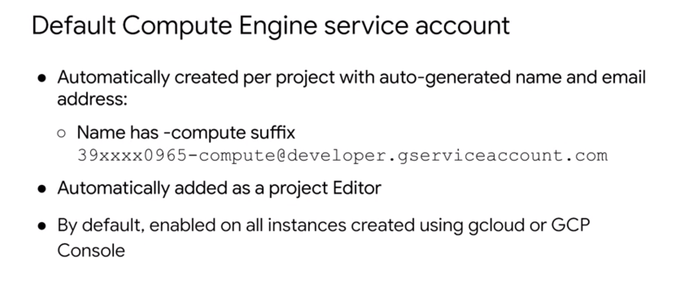

Authorization – what permissions an authenticated identity has on a set of specified resources.

Scopes are used to determine whether an authenticated identity is authorized.

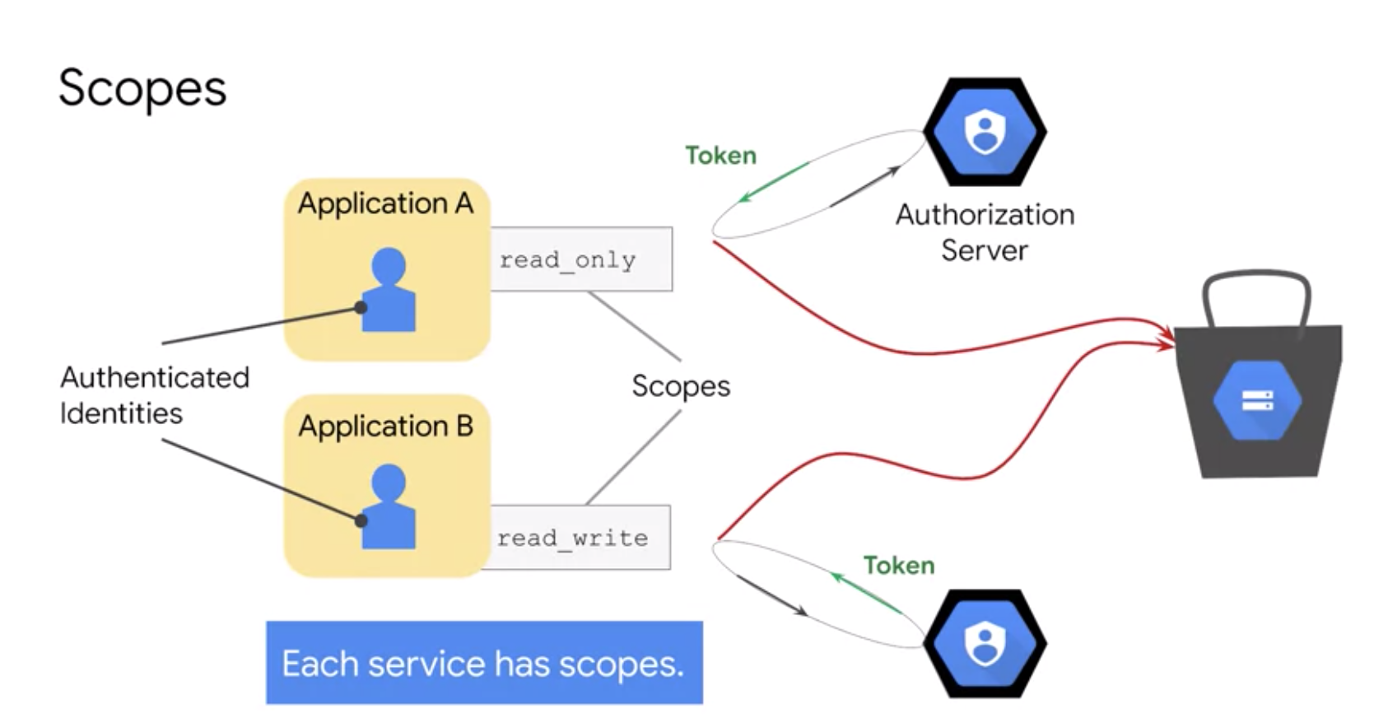

Scopes can be customized when you create a VM instance using default service account

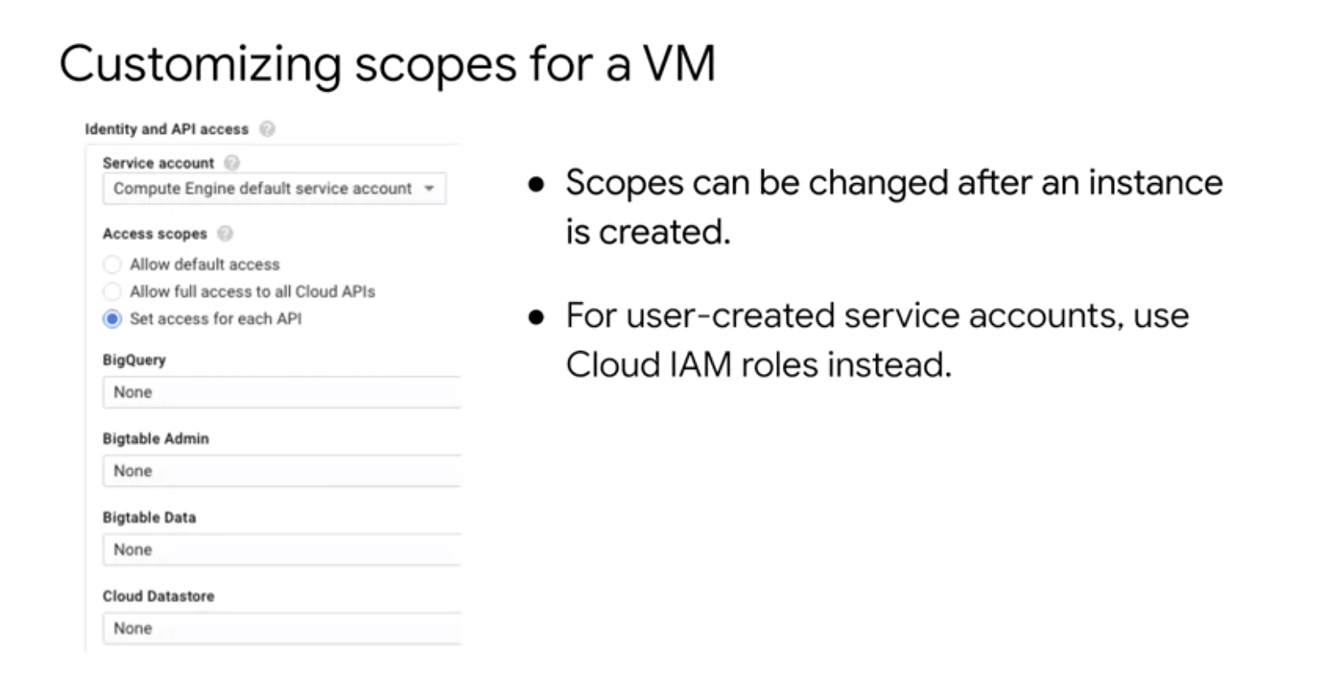

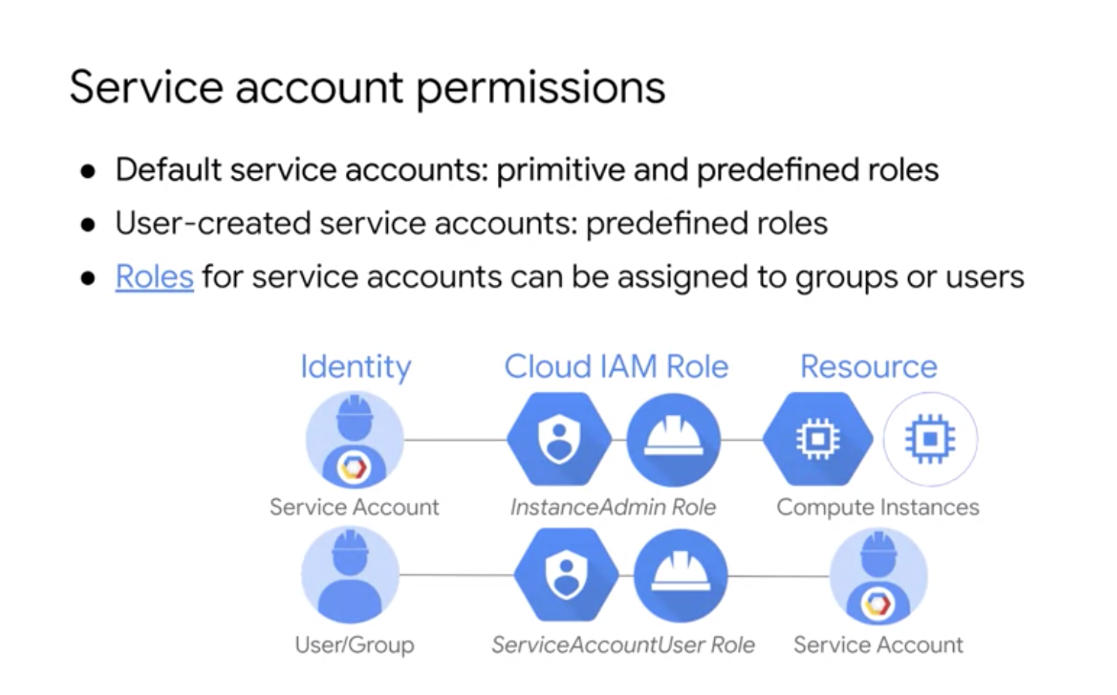

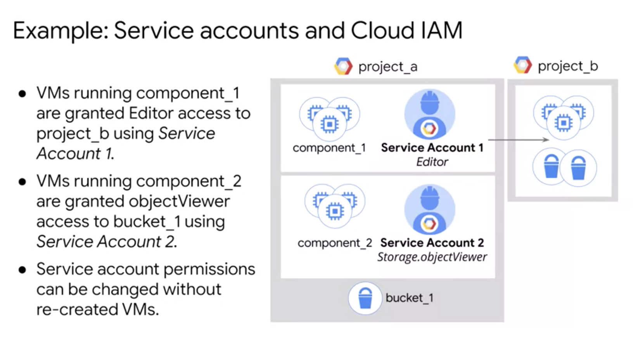

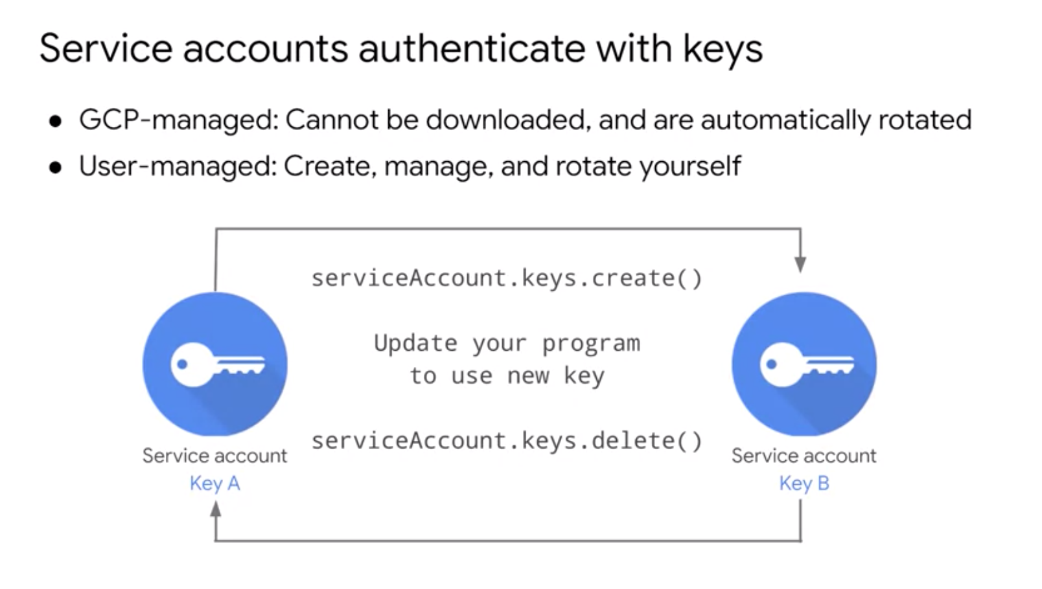

BEST PRACTICES

